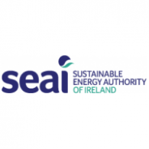
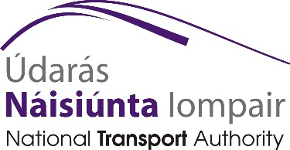

“Let’s Talk Cleaner Greener Transport”
Wednesday 4th April 2018
Mill Park Hotel, Donegal Town
Registration form
Email: donegal@locallink.ie Fax: 0035374 9732587
Personal Details:
Name: _________________________________________________________
Job Title: _______________________________________________________
Organisation/Company: ___________________________________________
Address: _______________________________________________________
________________________________________________________
Contact Phone: __________________________________________________
Email: _________________________________________________________
I wish to reserve ______ places at the “Let’s Talk Cleaner Greener Transport” Conference

**Book early as spaces are limited**

Light Lunch and other refreshments are included. Please advise if any special dietary requirements.
Please RSVP via email donegal@locallink.ie by Wednesday 28th March 2018

