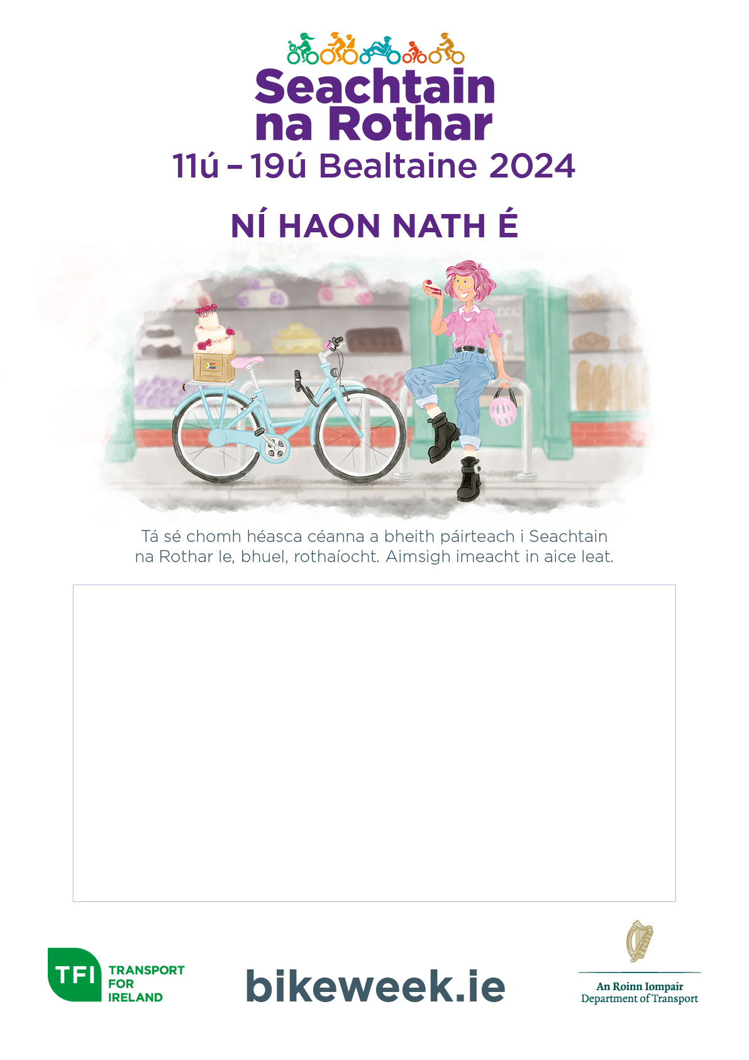

Description: **Leisure Cycle**

Date: **Saturday 13th May**

Time: **10am**

Start/Finish Point: **St. Anne’s Park,**

**Clontarf, Dublin 3**

Age Limit: **All ages and abilities**