- The following template can be used as a starting point for your social media plan.
- Add in your own local posts to inform and encourage people to take part in your local events.
- Sample social media images are included below. All available Social Media resources in both Irish and English are available to download at www.bikeweek/resources.

Date | Suggested FB/Instagram | Suggested Twitter | Suggested Image | Resource available
April | It’s nearly time for Bike Week! – May 11th – 19th  Bike Week is a celebration and promotion of all things #cycling. Bike Week 2024 will take place from Saturday 11th to Sunday 19th May 2024. There’s lots of events to look forward to held all throughout Ireland.  Check out bikeweek.ie for more information  #Bikeweek | Bike Week 2024, is coming! May 11th – 19th  Bike Week is a celebration and promotion of all things #cycling. Bike Week 2024 will take place from Saturday 11th to Sunday 19th May 2024. There’s lots of events to look forward to held all throughout Ireland.  Check out bikeweek.ie for more information  #Bikeweek | 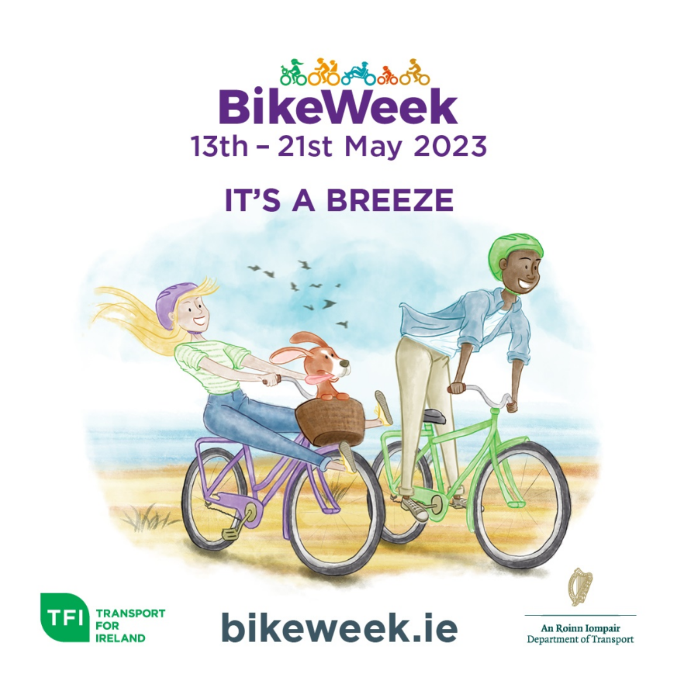 | Bike Week 2024 1 x 1 – It’s a Breeze – English

 | National Bike week is returning from 11th May. Check out bikeweek.ie to find out what’s happening in your County.  #Bikeweek  'Tá Seachtain Náisiúnta na Rothar ag teacht ar ais an 11 Bealtaine. Téigh chuig bikeweek.ie chun a fháil amach cad atá ag tarlú i do Chontae.'  #Bikeweek | National Bike week is returning from 11th May. Check out bikeweek.ie to find out what’s happening in your County.  #Bikeweek  ‘Tá Seachtain Náisiúnta na Rothar ag teacht ar ais an 11 Bealtaine. Téigh chuig bikeweek.ie chun a fháil amach cad atá ag tarlú i do Chontae.’  #Bikeweek |  | Bike Week 2022024 1 x 1– It’s a Breeze – As Gaeilge
Day 1 – 11th May | Here we go! It’s bike week day 1. We hope you are looking forward to nine days of cycling, fun, comradery and being part of a National Campaign! Let’s get ready to cycle  bikeweek.ie  #Bikeweek | Welcome to #BikeWeek. We hope you are looking forward to nine days of cycling, fun, comradery and being part of a National Campaign! Let’s get ready to cycle  bikeweek.ie  #Bikeweek |  | Bike Week 2024 - 1 x 1 – Piece of Cake – English

Day 3 – 15th May | #BikeWeek is underway. Check out www.bikeweek.ie to see what’s happening in your County. This is a great week to engage in a range of activities to get you back on your bike, improve your skills or most importantly just enjoy cycling! | #BikeWeek is underway. Check out www.bikeweek.ie to see what’s happening in your County. This is a great week to engage in a range of activities to get you back on your bike, improve your skills or most importantly just enjoy cycling! |  | Bike Week 2024 - 1 x 1 – Piece of Cake – English
Day 5 – 17th May | We’re at the halfway point of #BikeWeek 2024. Lots of people out cycling, joining events, and the schools are getting the children involved too.  Remember to check out bikeweek.ie for all the updates on events taking place in your local area. | We’re at the halfway point of #BikeWeek 2024 and it’s going fantastically. Lots of people out cycling, joining events, and the schools are getting the children involved too.  Remember to check out bikeweek.ie for all the updates on events taking place in your local area. |  | Bike Week 2022024 1 x 1– It’s a Breeze – As Gaeilge

Day 7 – 19th May | The fun factor gauge is rising! So many people are enjoying #BikeWeek. It’s wonderful to see the interest and to see so many bikes on our streets, parks, and on our fabulous Greenways. Keep it going and check out www.bikeweek.ie for all the information you need to take part. | The fun factor gauge is rising! So many people are enjoying #BikeWeek. It’s wonderful to see the interest and to see so many bikes on our streets, parks, and on our fabulous Greenways. Keep it going and check out www.bikeweek.ie for all the information you need to take part. |  | Bike Week 2024 1 x 1 – It’s a Breeze – English
Day 8 – 20th May | #BikeWeek ends tomorrow it’s a great chance to jump on your bike, join an event and have fun with family and friends. Check out bikeweek.ie for the details and come along and enjoy. | #BikeWeek ends tomorrow so make us happy by jumping on your bike and joining an event and having fun with family and friends. Check out www.bikeweek.ie for the details and come along and enjoy. |  | Bike Week 2024 - 9 x 16 – Piece of Cake – As Gaeilge

Day 9 – 19th May | #BikeWeek ends TODAY! What a fantastic fun filled week for everyone. Thank you to all the volunteers who assisted, thank you to the schools who ran events for the children and a BIG thank you to everyone who took part! We hope you enjoyed #BikeWeek and we look forward to seeing you on your bike in 2024. Thank you! | #BikeWeek ends TODAY! What a fantastic fun filled week for everyone. Thank you to all the volunteers who assisted, thank you to the schools who ran events for the children and a BIG thank you to everyone who took part! We hope you enjoyed #BikeWeek and we look forward to seeing you on your bike in 2024. Thank you! |  | Bike Week 2024 1 x 1 – It’s a Breeze – English

SEE FULL TOOLKITT FOR ALL ASSETS

Tips:
For social media it might be worth asking a question within a tweet or post to generate engagement. For example, “We are half-way through bike week! What events have you taken part in so far? We’d love to see you on your bike, so make sure to tag us at (insert handle here, for example @tfismartertravel)”

Change www.bikeweek.ie to bikeweek.ie saves on space and the domain is the same (better for Twitter)

Only use the #bikeweek once per post

Might be worth having a list of emoji’s or even encouraging the use of them to highlight the fun element, here is a screenshot of examples you could include that might fit well:

